8Splash Test Dummies
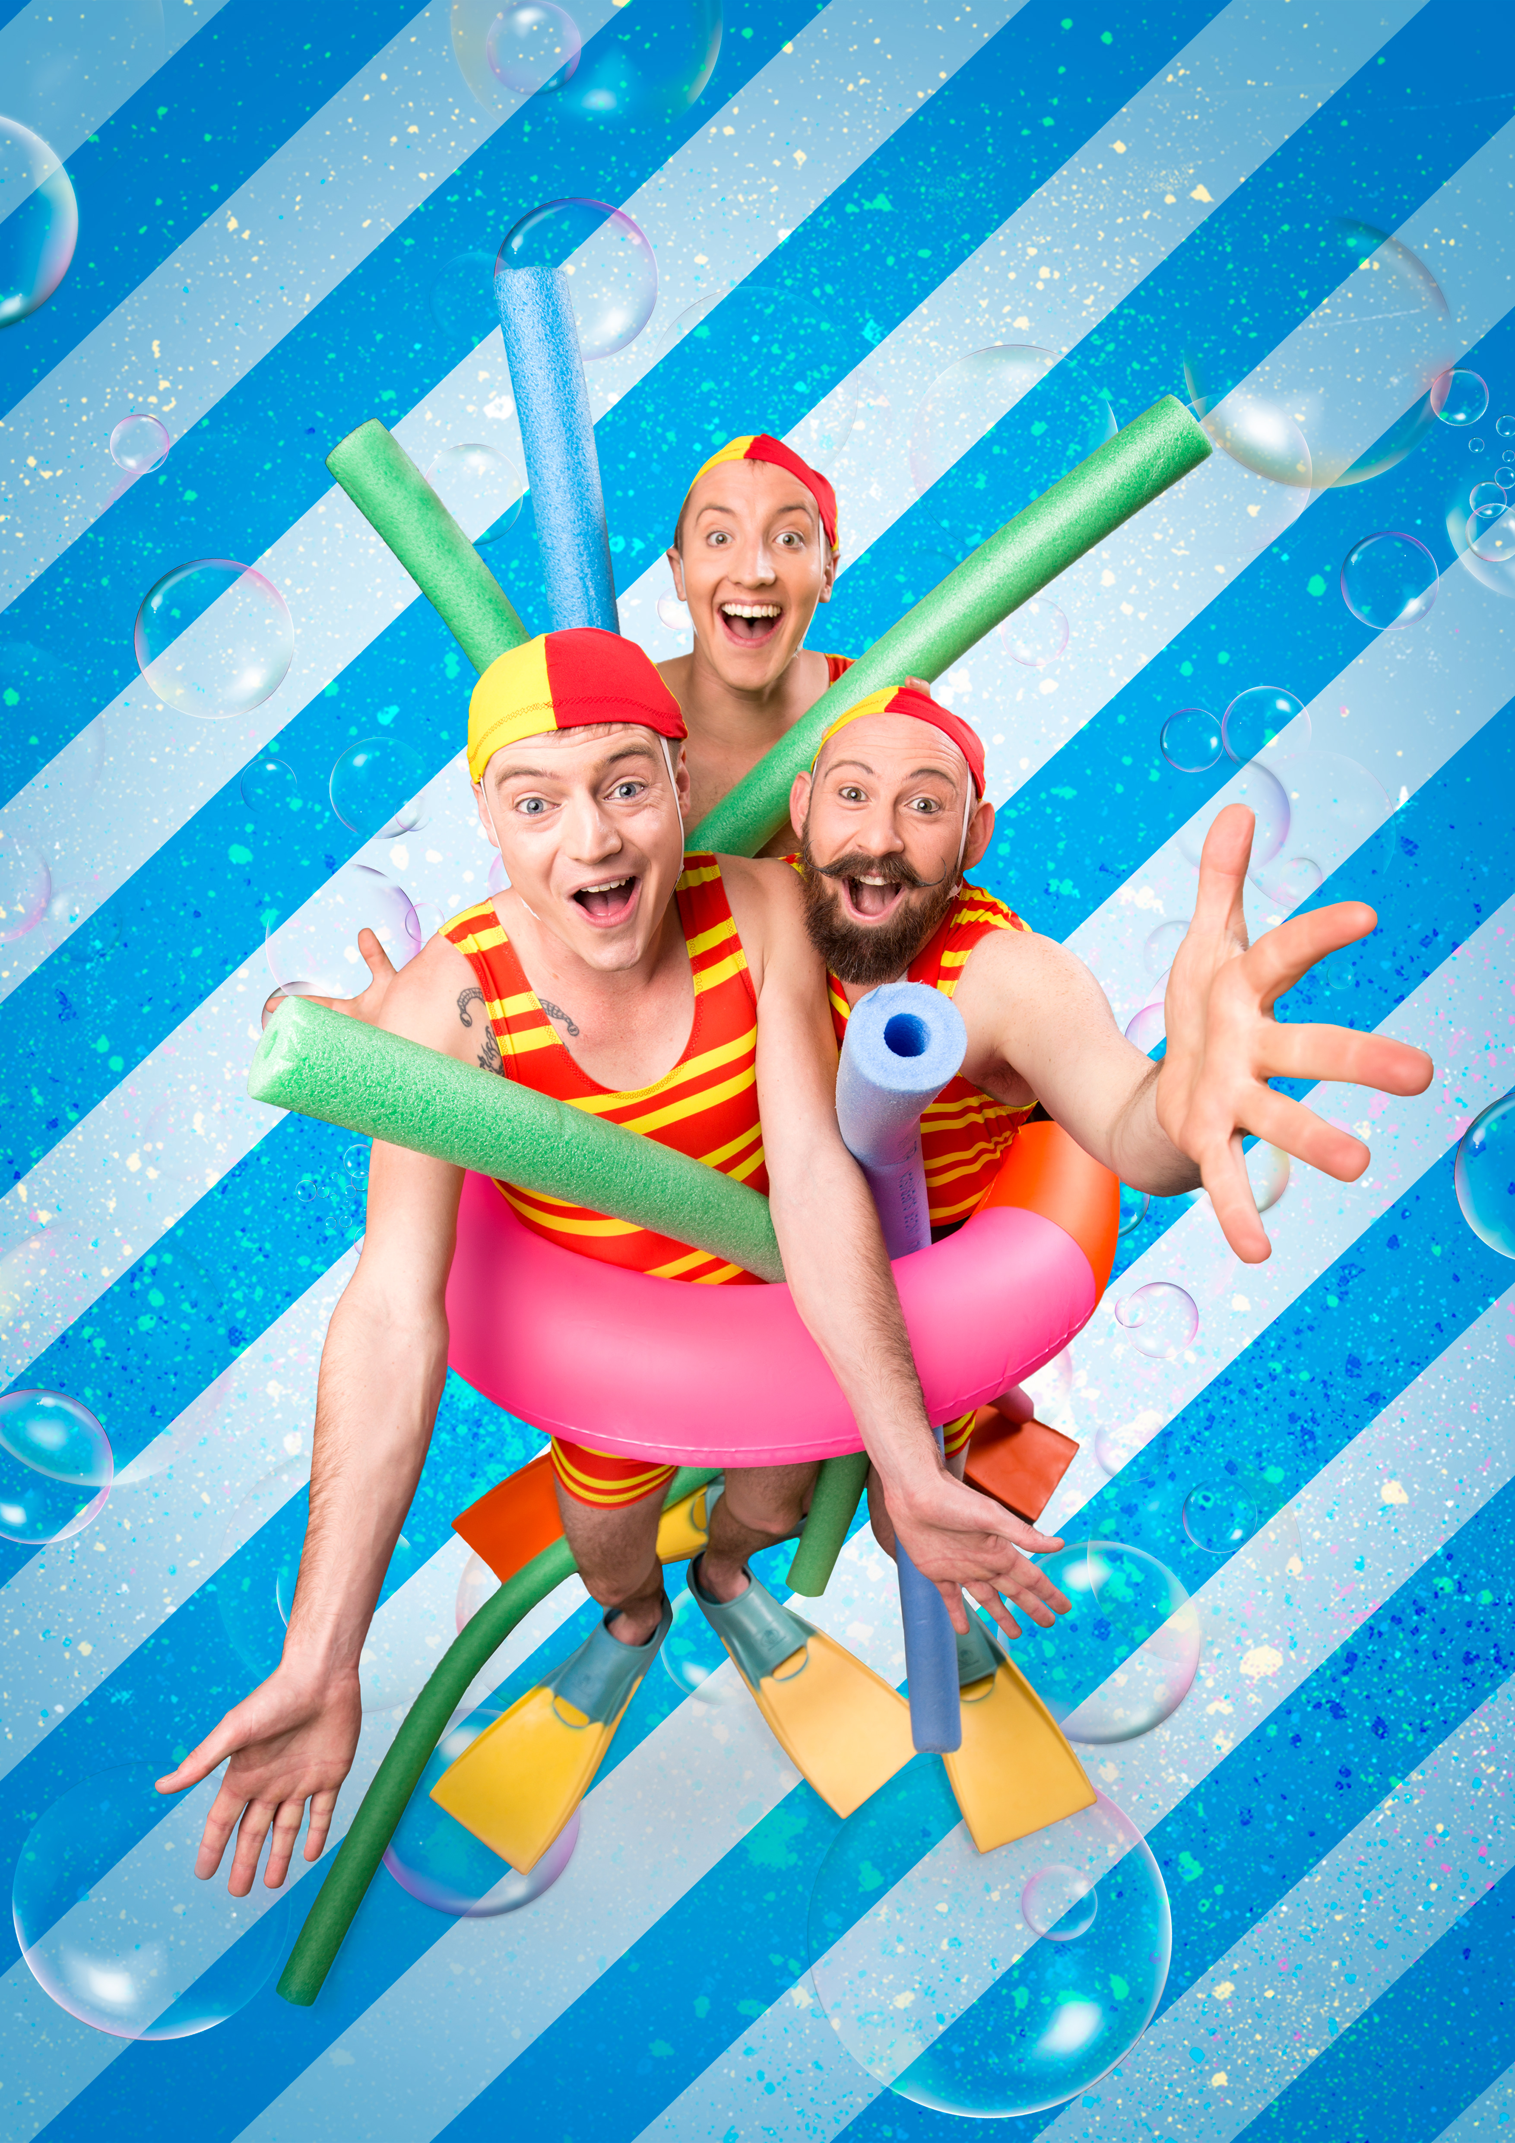
By Trash Test Dummies
Presenter Information

Contents

COMPANY PROFILE 3
ABOUT THE SHOW 3
PERFORMANCE SPECIFICS 4
AUDIENCE ENGAGEMENT 5
MARKETING 5
PRODUCTION DETAILS 6
CONTACTS 8

COMPANY PROFILE
Jamie Bretman, Jack Coleman and Simon Wright are highly skilled circus performers who created Trash Test Dummies in 2013 and have been touring nationally and internationally ever since. They have performed for sell out crowds and have been critically acclaimed in Australia, Asia and Europe winning a host of awards including the coveted Best Children's Presentation at Adelaide Fringe Festival 2015. The company are firm favourites on the Edinburgh Fringe Festival program each year and continue to delight fans young and old with their trademark blend of circus, comedy and imagination.
They have successfully toured Trash Test Dummies with arTour and now have their new show Splash Test Dummies which is an action-filled adventure ready to tour in 2018.

Praise for Trash Test Dummies:
'Circus and acrobatic show perfect for families' ***** (EdinburghFestivalFor Kids.com).
‘Adept, unadulterated mischief’ **** (Times)

ABOUT THE SHOW

SHOW SYNPOSIS

Rub-a- dub-dub, The Dummies are back with some splish splashing circus set to drown you in tears of laughter.

From the makers of hit show Trash Test Dummies comes a new production of oceanic proportions! Splash Test Dummies are here, ready to roll out their beach towels and spring into a brand new hour of circus-filled hilarity for the whole family. See a brilliant array of catch-your-breath stunt work, acrobatics, juggling and the side-splitting, slapstick comedy for which the dummies are famous.

Join the Dummies and come diving from bathtubs to beaches in this new aquatic adventure!

Trash Test Dummies have been delighting audiences young and old with a nuanced blend of circus, comedy and imaginative play, creating shared and treasured experiences for families across Australia and around the world. Now, they're ready to take you on a new adventure.

ACKNOWLEDGEMENTS
Created by: Jamie Bretman
Simon Wright
Jack Coleman
Director: Claire Bartholemew
Liz Skitch
Producer: Lauren Eisinger
Lighting Design: Chris Payne

BIOGRAPHIES

Jamie Bretman

Jamie has a background in theatre and live music-- including drums, guitar, piano, ukulele and piano accordion-- and progressed into circus and acrobatics. A graduate of both CircoArts in New Zealand and the National Institute of Circus Arts (NICA), Australia, Jamie has toured with New Zealand’s Circus Aotearoa, performed at Sidney Myer Music Bowl, Tasmanian Circus Festival, and hundreds of independent cabaret and circus productions. His specialties include partner acrobatics and pass juggling.

In his graduating year at NICA Jamie co-founded the company Almost Exactly Circus and co-wrote, directed and devised their first ensemble show Minimum Stay. The following year Minimum Stay toured along the east coast of Australia and performed at the Adelaide Fringe festival to stand out reviews.

In 2013 Jamie joined forces with Jack and Simon to create and tour Trash Test Dummies.

Simon Wright

Before training in circus, Simon trained as a competitive swimmer. With a passion for the ridiculous he has perfected skills that most people think impossible such as juggling ping-pong balls with his mouth. In his years training at the National Institute of Circus Arts, he became one of Australia’s best unicyclists and freestanding ladder balancer.
He has performed at Cirque de Demain in Paris in 2012 and stars in the ABC kids circus show “Hoopla Doopla” as Zap.
Together with Jack and Jamie he developed Trash Test Dummies in 2013 and been touring nationally and internationally since then.
Jack Coleman

Jack Coleman is a hilarious, ridiculous and captivating entertainer. He has a variety of interesting and impressive skills which range from aerial straps, unicycle, handstands, acrobatics, juggling, and an adagio flyer. Jack had ten years of gymnastics training by the time he decided to study circus at National Institute of Circus Arts. After graduating Jack, Jamie and Simon developed Trash Test Dummies which has been in constant demand since 2013.

PERFORMANCE SPECIFICS

DURATION
Show runs 60 mins, no interval.

SUITABLE VENUES
Ideal venues are proscenium arch or thrust stages where there is wing space with black masking and adequate space side of stage for prop storage.
However show can be adapted for outdoor or other venues on negotiation with company.

MAXIMUM NUMBER OF PERFORMANCES PER WEEK
8 performances
No more than 3 consecutive days with 2 performances per day.
After 3 consecutive days of 2 performances per day, company need rest day.

MINIMUM BREAK BETWEEN PERFORMANCES
120 minutes

LICENCING AGREEMENTS
Nil

APRA OBLIGATIONS
APRA licenced music used, venue to acquire and pay for Dramatic Context APRA licence.
If venue does not have standing APRA arrangement, company can organise by prior negotiation.

TOURING PERSONNEL
The touring party consists of 4 people.

Name | Role
Jamie Bretman | Performer
Simon Wright | Performer
Jack Coleman | Performer
Chris | Technician/ Stage Manager

PERFORMANCE HISTORY
Year | Venue | Number of performances
2017 | Mullum Circus Festival | 2
2018 | Tasmanian Circus Festival | 2
2018 | Adelaide Fringe Festival | 28
2018 | Melbourne International Comedy Festival | 15
2018 | Regional Victoria Tour | 15

AUDIENCE ENGAGEMENT

OVERVIEW
Company can offer two different types of workshops to local community whilst on tour, a clowning/slapstick focused workshop and a circus skills workshop.
Each workshop can cater for up to 30 participants ages 6+ and lasts for an hour. Participants don't need any prior ability and will leave having learnt some of the moves they have seen in the show, creating a strong connection between the performance, the artists and their own experience.

Both workshops, like the show, place great emphasis on creative play and empower participants to carry this imaginative embodied experience into their lives beyond the workshop. Workshops encourage individuality in creation, embodiment of skills and interpretation meaning that even once the company have left, participants can continue creation and play which encourages self sustaining creative communities.

COST
Cost of $600 billed to Presenter for 1 hour workshop. Up to 30 participants ages 6+

TARGET AUDIENCE FOR COMMUNITY ENGAGEMENT
Workshops are for people with little or no experience in circus arts or clowning.
Workshops suitable for ages 6+

MARKETING

MARKETING COPY

One line
Rub-a- dub-dub, Splash Test Dummies are here with some splish splashing circus set to drown you in tears of laughter.

Short

Rub-a- dub-dub, The Dummies are back with some splish splashing circus set to drown you in tears of laughter.
From the makers of hit show Trash Test Dummies comes a new production of oceanic proportions! Splash Test Dummies are here, ready to roll out their beach towels and spring into a brand new hour of circus-filled hilarity for the whole family. See a brilliant array of catch-your-breath stunt work, acrobatics, juggling and the side-splitting, slapstick comedy for which the dummies are famous.
Join the Dummies and come diving from bathtubs to beaches in this new aquatic adventure!
Praise for Trash Test Dummies:
'Circus and acrobatic show perfect for families' ***** (EdinburghFestivalFor Kids.com).
‘Adept, unadulterated mischief’ **** (Times)

MEDIA QUOTES
Full list of media quotes and audience reviews available at www.trashtestdummies.com

VIDEO LINKS
Video available on request

IMAGES
Production images available on request

MARKETING MATERIALS

Company has the following marketing resources:

- website and print copy in varying lengths

- poster artwork

- double sided flyer artwork

- portfolio of images

- trailer

- b-roll footage

publicity resources:

- media release

- media images

CONTENT WARNINGS / AUDIENCES TO AVOID
no

SPONSOR OR OTHER ACKNOWLEDGEMENTS
no

TEACHER’S RESOURCES
Currently in development.

PRODUCTION DETAILS

EXAMPLE SCHEDULE
0900 company have access to venue, unload truck
bump in commence
1400 break
1500 show call
1600 performance
1700 pack down
Bump out
1800 company clear of venue

CREW REQUIRED FROM VENUE
Induction required from a venue technician to the venue’s lighting and AV equipment. Company tech will operate and stage manage

STAGE
Minimum stage: 8m x 6m
Minimum height: 4m
Black masking wings
Black masking upstage

LIGHTING
Venue to provide:

10x Par 64 LED
6x Fresnel
4x Profile
6x Par 56
24 Dimmer channels
3x Moving lights

The technician of Splash Test Dummies travels without a lighting desk. A desk with cuestack is a must as well as one local technician who knows that desk well.

SOUND
Venue to provide:

Powerful, full frequency range, good coverage system

Analog sound desk
4 channel min
Auxiliary input required for Audio playback

WARDROBE
Access to washing machine and dryer preferable but not essential
Dressing room access required 2 hours prior to performance

FREIGHT NOTES
Company travel with freight in 1 tonne van.
Venue to provide access to loading dock.

CONTACTS
Producer/ Publicity:
Lauren Eisinger – 0415 254 894/ producer@laureneisinger.com

Company Manager/ Technical:
Jamie Bretman – trashtestdummies@gmail.com

